TEAM PROFILE FOR THE APPOINTMENT OF A HOUSE FOR DUTY
ASSOCIATE PRIEST TO SERVE THE PARISH OF WHITCHURCH
WITHIN THE LANGTREE TEAM MINISTRY

The Appointment
The Bishop of Dorchester and the Team Rector are seeking to appoint an Associate Priest to serve the parish of St Mary’s and St John’s Whitchurch in the Langtree Team Ministry. The Langtree Team is in a large area of outstanding natural beauty and lies at the southern end of the Chilterns. It is in the Henley Deanery and the Dorchester Archdeaconry of the Diocese of Oxford. The villages of Whitchurch-on-Thames and Whitchurch Hill are in the part of the Langtree team area where the river Thames flows through the Chiltern hills.
The Langtree Team was formed in 1981 with Checkendon, Stoke Row and Woodcote. In 1993 it was enlarged to include the parishes of Ipsden and North Stoke with Mongewell. The Team was further enlarged in 2003 to include the parish of Whitchurch and Whitchurch Hill. The combined electoral roll (2019) for our parishes was 308.
The Team’s complete ministerial staff has the Team Rector serving Checkendon and Stoke Row, a stipendiary Team Vicar at Woodcote and non-stipendiary Associate Priests on a house-for-duty basis serving (a) Ipsden and North Stoke and (b) Whitchurch and Whitchurch Hill. There is a licensed Reader, a non-stipendiary Team Pastor, a licensed lay preacher and a part time Administrator.
The Langtree Team staff provide support for the parishes in developing their response to local ministry needs. Churchmanship across the parishes is central and unfussy.
Each parish in the Team has its own churchwardens and PCC. Each appoints two representatives to the Team Council which meets quarterly. Parishes contribute funds to cover the expenses of the Team, for the staff, team office and parish requisites, but in every other way the parishes are financially independent of each other. Each parish maintains one or two church buildings and a churchyard, the parish quotas are paid in full and all buildings are in good order. The Team Office at Stoke Row has copying and printing facilities, and the paid Administrator is available to assist all the ministry team in the desk bound aspects of ministry.
Our website and Facebook pages give a good perspective on the ministry we share.
www.langtreechurches.org
www.facebook.com/langtreechurches
The Team's main priorities are the provision of worship on a regular basis at each of the member churches and pastoral care that is both realistic and appropriate. There are many opportunities for Christian witness and fellowship in the communities that we serve, and the Team Council encourages an adaptable, creative response to these by PCCs and staff team members.
Whilst the House for Duty vacancy will be primarily involved with parochial ministry in Whitchurch, the Team staff are expected to be flexible in their approach to ministry, so that, for example, holiday leave or other absences may be covered elsewhere in the Team.
WHITCHURCH-ON-THAMES AND WHITCHURCH HILL

Whitchurch on Thames
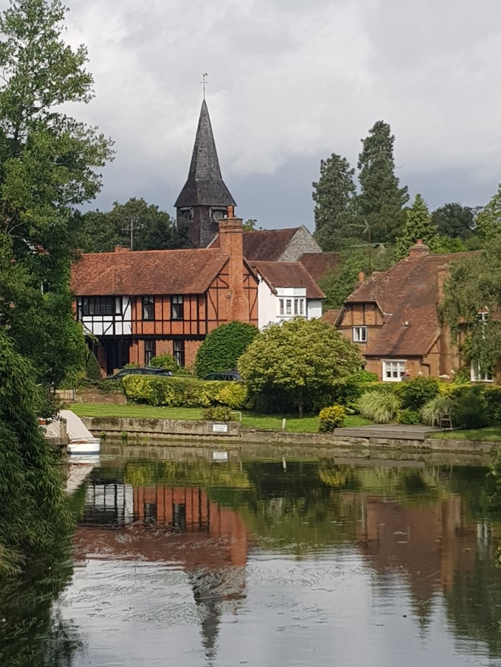
Whitchurch on Thames is the second largest village in the Team ministry area. The combined population with Whitchurch Hill is about 1800.
As well as the facilities and natural beauty of the river Thames in this part of the Chilterns AONB, Whitchurch has two pubs, a village hall, and a state primary school. Crossing the river via the Toll Bridge (60p per car) gives access to the amenities of Pangbourne; the surgery, shops, garages, library and mainline railway station making journeys to both Reading, and London fast and convenient. There are two ‘big’ houses in Whitchurch parish: Hardwick House and estate with organic farming and horse livery, and Coombe Park which has recently been purchased and is awaiting development.
The Thames Path long distance national trail runs down the High Street and by St Mary’s Church which is open every day. Weekly services are held at St Mary’s and St John’s catering for both traditional and informal tastes in worship. The mill pool at Whitchurch on Thames
The ancient parish church of St Mary the Virgin, the largest church building in the Team, is largely the result of Victorian rebuilding by Henry Woodyer, although fragments of the medieval fabric remain. It has seating for in excess of 300 and an excellent organ by J.W. Walker & Sons of London. The electoral roll (2019) is 49, the parish share (2019) is £24,636. Occasional offices annual averages are funerals 8-10, weddings 2-4 and baptisms 5-6.
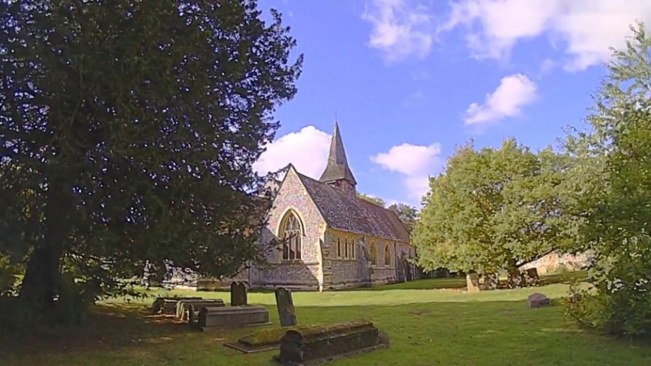
Our church facilities have been transformed over the last decade, with a new purpose-built vicarage, and a new parish room in ‘The Old Stables’ of the historic Rectory.

Click here to view our welcome video
View of St Mary’s Church from the churchyard

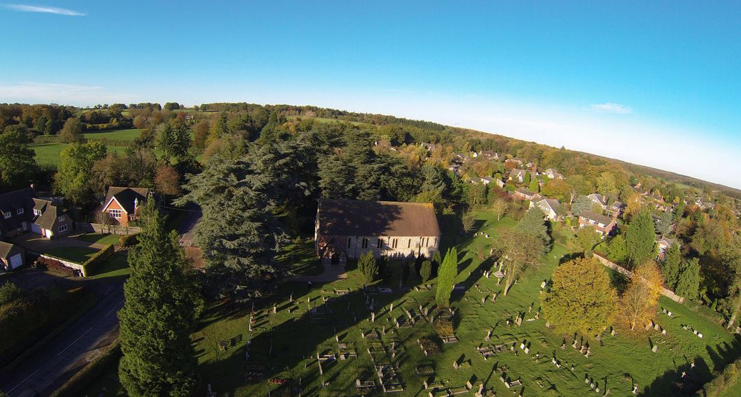
Whitchurch Hill
Aerial view of St Johns Church and churchyard, with Goring Heath Parish Hall on the left, and the settlement of Whitchurch Hill to the right.
Up the hill from Whitchurch on Thames lies the smaller sister settlement of Whitchurch Hill. Most of this village comes under the aegis of Goring Heath Parish Council.
Whitchurch Hill is a more rural community than Whitchurch on Thames, with one pub, but no shop or school and a one day a week bus to Reading. Children here can choose between Whitchurch on Thames or Checkendon schools. The Castrol Technology Centre is a research institute owned by BP and based at Bozedown House.
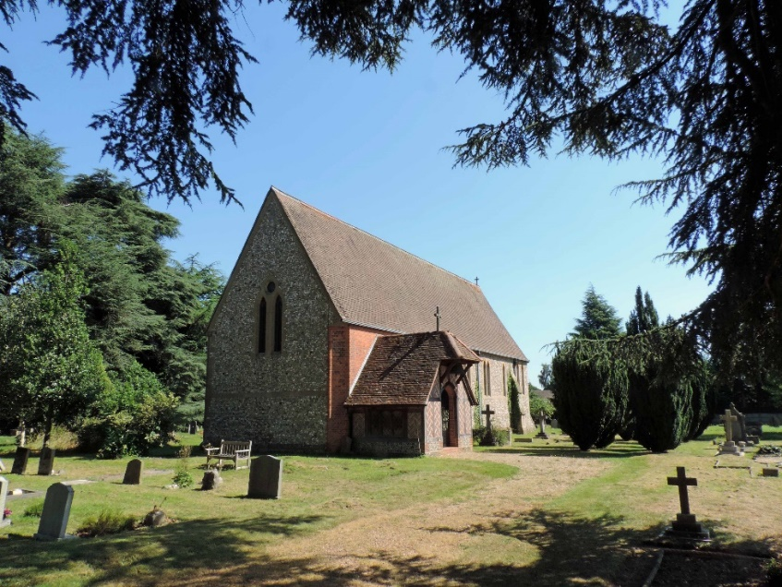
The Church of St John the Baptist is an Anglican chapel of ease built and consecrated in 1883 for the uphill residents in opposition to the then thriving Methodist chapel (now closed). It seats about 100. It has a very large churchyard which serves the whole parish.
Church services in our parish alternate between the two churches and the congregations are largely the same, with more focused and informal "All-Age Worship" at St John's twice monthly. It also benefits from a J W Walker and Sons organ.
It is a simple building of flint and stone with tiled roofs and paired lancet windows, comprising chancel and nave in one, with an apsidal east end and a north vestry.

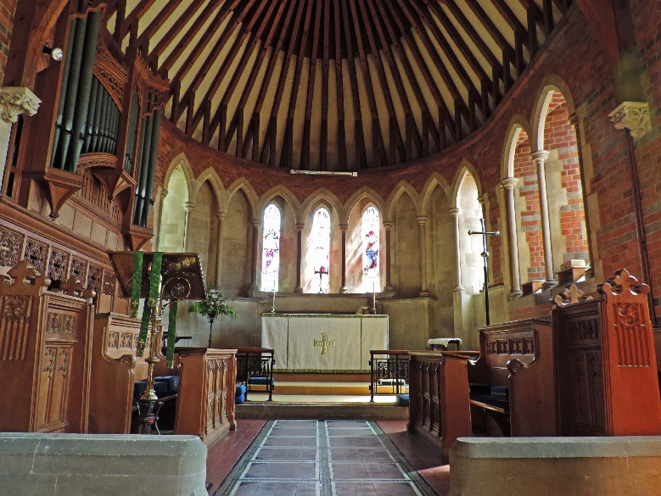
St John’s is blessed with a car park opposite, together with Goring Heath Parish Hall. This was originally built as a Sunday school for St John’s but is now owned and run by Goring Heath Parish Council. It is often used by the church for events such as Harvest Supper and serving mulled wine and mince pies after the popular Nine Lessons and Carols service. The large village green adjoins the church, and a very popular village fete is held there every May Bank Holiday.
Interior of St John’s Whitchurch Hill
The Friends of St Mary’s and St John’s through member’s subscriptions and fund-raising pay for improvements to the two churches, having recently installed a sound system at St John’s and repaired the clock on St Mary’s. Quotes are currently being obtained to replace the altar frontals’ cupboard in St Mary’s and it is expected the Friends will also contribute in some way towards kitchen and toilet installation at St John’s, currently in the early planning stage. The post holder can expect an invitation to serve as a Trustee of the Friends.
There are comprehensive village websites at www.whitchurchonthames.com and www.goringheath.com. Further historical information on the two churches can be found here: VCH Oxfordshire Whitchurch Religious History.
The Old Stables Church Room, Whitchurch on Thames.
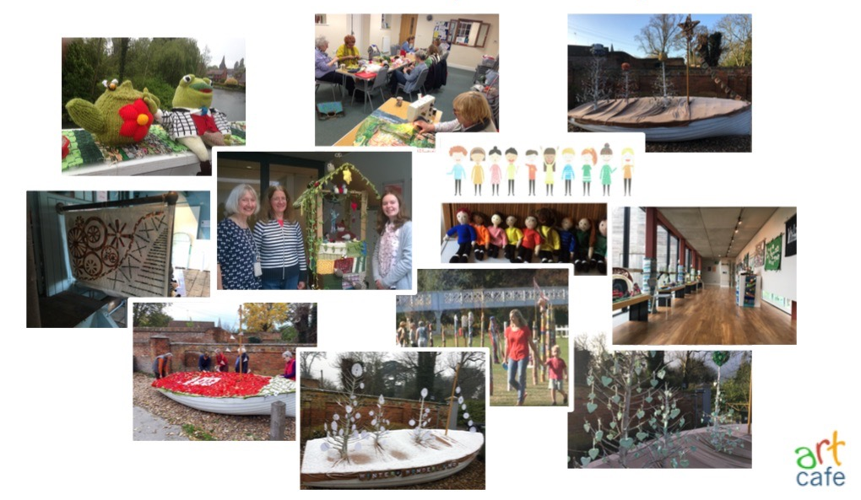
The Old Stables is used for prayer and Bible study groups and other activities including Community Coffee mornings every Tuesday during term time, Lent Groups and Lent Lunches, PCC meetings. This room is also used for regular village activities including yoga, band practice, crafty knit and stitch, and the extremely popular charity fundraising Art Café every Saturday morning. It provides us with a useful way to engage with our community when formal “church” might be a step too far for some.
Other Whitchurch Groups and Charities
The post holder will also be a Trustee of the Whitchurch United Charities, a registered small educational charity for the benefit of young people in the parish. Bell ringers meet at St Mary’s where there is a tower with six bells. There are three organists and a small choir at Communion Services, augmented for special services. A bible group and prayer meetings gather regularly in homes around the parish.
Whitchurch is a lively community with plenty of scope for both social enjoyment, and useful service. The following are just a few examples of active groups:
WoTHabs is a Parish Conservation Group – an enthusiastic team of residents who work together in Whitchurch to 'Think Globally, Act Locally' on environmental projects in their area. The Pangbourne and Whitchurch Sustainability Group (PAWS) was founded in 2010 as not-for-profit community organisation with the aim to promote and encourage the development of a sustainable local community. The Green Team is a group of both core and ad hoc volunteers who help look after and maintain the green spaces in the village.
The Whitchurch Society organises the annual Art and Crafts Exhibition, displaying video, photography, art and craft of all types, showcasing all the talent in the village of all ages including local schools in South Oxfordshire.
WoTsing offers a get-together for all who like to sing, meeting in St John’s once a month.
Whitchurch Handbell Ringers meet on Friday evenings in a home. WOTJammers are a jazz group who play for fun for a couple of hours in the Old Stables each week.
Path Hill Outdoors is a not-for-profit company based at Path Hill Farm in the parish of Whitchurch. It offers educational programmes, primarily for children who are not flourishing in a conventional school. And at Crays Pond near Whitchurch Hill there are Cubs, Beavers, Scouts and Guides groups and a bowls club.
The French Connection.
Our villages have been twinned with La Bouille in Normandy since 1976. On the May Day bank holiday weekend a group goes to France in the even-numbered years and hospitality is reciprocated with French guests visiting Whitchurch in the odd-numbered years. Many lifelong cross channel friendships have been made.
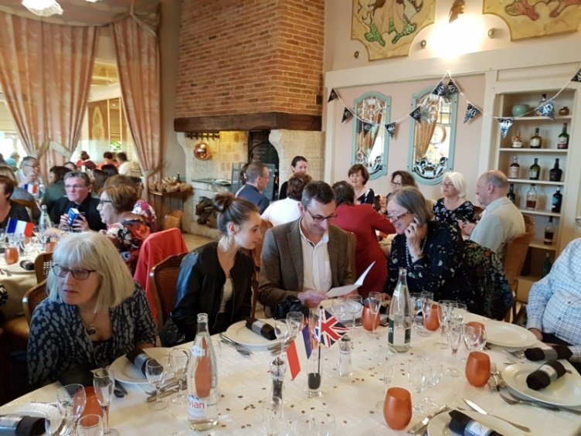

40th Anniversary Celebration In La Bouille

Whitchurch Parish Priorities.
It will be important for our new priest to work closely with the PCC in evolving priorities for ministry, which meet the needs of the parishes and utilise his or her particular skills, but the following areas for possible development in ministry have been identified by the church:
- Helping us to discern where God is at work in our village, and seeing if there are ways that we as a Christian community can join in.
- Connect with local families and Whitchurch Primary School, develop relationships and explore new forms of ministry with children and young adults.
- Walking with us on the Partnership for Missional Church programme and exploring the associated spiritual practices, such as Hospitality.
- Work with the Friends and others to increase the flexibility of the church buildings make them fully accessible and equipped for the needs of our community today.
- Encourage Christian discipleship among Church members, developing our vocabulary and confidence in talking about our experience of God and sharing our stories of faith.
- Help us to enjoy our faith, involving a wide variety of people in leadership and worship.

Pattern of Worship at Whitchurch on Thames and Whitchurch Hill
1st Sunday | 9.30am | Parish Communion | Whitchurch on Thames | Common Worship
2nd Sunday | 11am | Family Communion | Whitchurch Hill | Common Worship
3rd Sunday | 9.30am | Parish Communion | Whitchurch on Thames | Common Worship
4th Sunday | 08.00 am  11am  6pm | Holy Communion  All Age Worship  Evening Prayer | Whitchurch on Thames  Whitchurch Hill  Whitchurch on Thames | BCP  Common Worship  BCP
5th Sunday | 10.30am | Team Celebration | A single service somewhere in the Team Ministry Area | Common Worship

The above is a simple outline of the basic pattern at Whitchurch on Thames and Whitchurch Hill. On a given Sunday there are between 7 and 10 services held across the Team Churches, in a wide variety of styles.
The Team Ministry offers seasonal templates for regular services such as Holy Communion. The Team Rector actively encourages each parish to develop and adapt its worship pattern to changing needs. Each ordained minister normally spends three Sundays each month at his or her designated church(es) and one Sunday elsewhere. The service plan also involves the Licensed Lay Minister, visitors, and other lay helpers.

What do we offer?
- A welcome to a beautiful part of Oxfordshire from an established, friendly and hospitable benefice
- A church with healthy finances and with lay people fully involved and leading on key projects including church buildings
- A location close within easy reach of Reading, Oxford and London
- A well situated, comfortable Vicarage (further details below)
- The encouragement and active support of Church Wardens, PCC and congregation
- The help and assistance of enthusiastic, able volunteers and lay leaders
- Assistance from the benefice office, and an experienced team administrator
- Respect for your time off. A Diocesan agreed holiday entitlement, pro rata.
- Active support for anything that encourages and nourishes your faith and well-being, including continuing education, spiritual support and annual retreats
- A friendly and active Deanery, in a professional and forward-looking Diocese

Vicarage and Location
The Vicarage (“St Mary’s House”) is situated in the village of Whitchurch on Thames adjacent to the church. It is an excellent modern four-bedroom detached house with a large kitchen, a study and two reception rooms. It also has a double garage, a large garden and car parking space.
Pangbourne village shops and post office are within walking distance. There is also a GP surgery in Pangbourne a short walk across the river as well as a regular train service to Reading, Oxford and London. St Mary’s House was completed in 2011
Within the parishes of the Langtree Team, there are primary schools at Whitchurch on Thames, Woodcote, Checkendon(C/E) and Stoke Row(C/E), and a secondary school Langtree School at Woodcote, three miles north of the village. All the schools are rated at least ‘Good’ by Ofsted with Whitchurch Primary rated Outstanding.

Person Specification
As a village community we would welcome any practical and spiritual gifts you may bring. In addition to this we are looking for following qualities in the new Associate Priest:
- A firmly grounded personal faith expressed with tolerance and a sense of humour.
- An understanding, and preferably experience, of rural communities.
- A heart for children and young people in our villages and the ability to work with others to develop new ways of ministering to them.
- Perseverance and cheerfulness in working with differing sizes of congregation.
- Personal maturity and stability.
- Well organised, and computer literate. Full UK driving license.
- A good listener who can relate to a wide range of people and their needs.
- A willingness to participate in community life. A gift of spiritual discernment to see God’s hand at work both in individuals and in the wider community.
- Ability to work collaboratively, contributing to the support and fellowship of colleagues across the Team Ministry and Deanery.

Duties and Responsibilities
The Associate Priest will be licensed to the Team for a period of 5 years, with responsibility for the Parish of Whitchurch. The appointment is on a “house-for-duty” basis. This means that no stipend is paid, but the postholder will reside rent-free in St Mary’s House in Whitchurch on Thames on the same basis as an incumbent. In return, the postholder is expected to carry out all the usual pastoral and ministerial responsibilities of an incumbent, including chairing of the PCC (or sharing this task with the lay chair) and attendance at the quarterly Team Council meetings.
The time commitment involved is the equivalent of two full days per week plus Sundays. Expenses are reimbursed in full, in accordance with Diocesan guidelines. A working agreement will be drawn up and reviewed annually with the Team Rector, to whom the postholder is accountable.
Within these time constraints, the Associate Priest should expect to participate fully in all the activities of the Team, which will include taking services in other churches in the Team, attendance at Staff meetings, covering for sickness or holiday and, following consultation with the Team Rector, any other specialist or general pieces of ministry (for example, church school governance) as appropriate. Sharing in the life of the Henley Deanery is expected.

The Other Parishes of the Langtree Team Ministry.

Checkendon
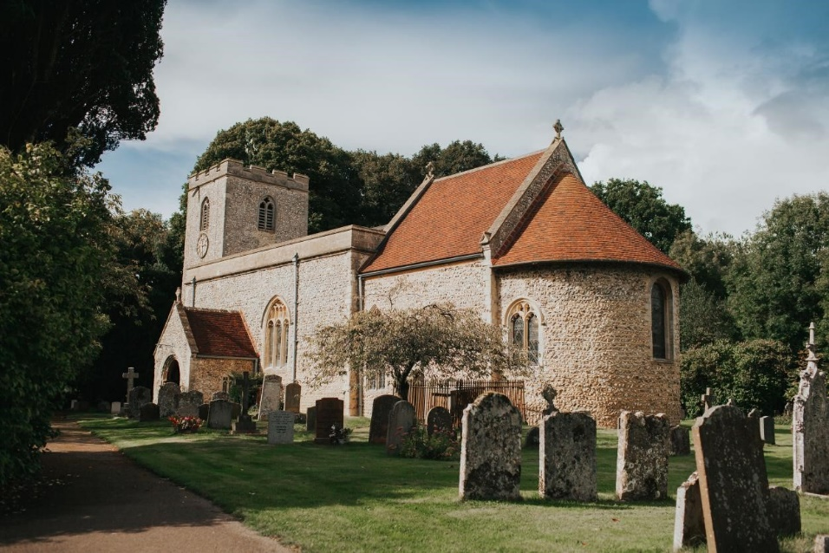
This pretty village has about 470 inhabitants. The medieval church of SS Peter & Paul dates from 1152 and unique wall paintings were discovered at the turn of the millennium. Checkendon is an “iconic” church which attracts many worshippers and visitors to its sacred space. There was a complete re-roofing in 2012 at a cost of over £300,000. The church can seat approximately 120 people and like all the Langtree Churches has an open churchyard. There is a flourishing children’s ministry "Sunday Fun", based in the neighbouring C of E (Aided) primary school. This has about 70 pupils drawn from surrounding parishes. There is a village hall, preschool, equestrian centre, excellent pub, and several small businesses. www.checkendon.org

Stoke Row
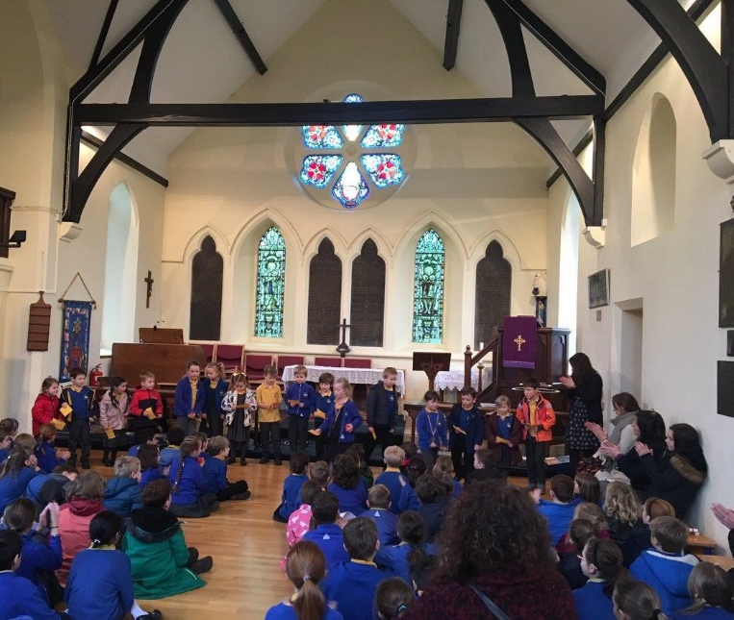
This woodland parish has a small Victorian flint church built in 1846. There is a population of about 640 people and the village has a C of E (Aided) school with about 90 pupils which has recently become voluntary aided in status. There is a village hall, sports pavilion, shop and two pubs. There is also a non-conformist Chapel served by a Baptist minister. Stoke Row is a very active village, with many local clubs and organisations.
The parish church and Team ministry collaborate with the Chapel and the school in many areas. St John’s might be the smallest church in the Team, but it is very forward thinking. It was the first church in the Team to have an integral toilet and kitchen, and the imaginative reordering has enabled the school to use the building as their hall under licence for four days a week during term time. Last year St Johns became the first church in the Team to offer WiFi Internet. www.stokerow.net.
Stoke Row schoolchildren in St John’s Church, Stoke Row

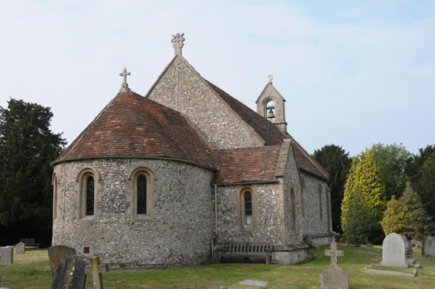
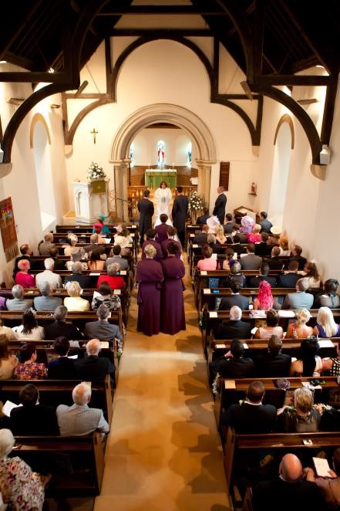
Woodcote

Woodcote is the largest village in the Team. It has almost 3000 inhabitants, many of whom work in London and Reading as well as locally. There is primary, secondary, private and pre-school provision. St. Leonard’s church dates from the 12th century. It was completely rebuilt in 1846 and has an interesting history since it was originally the daughter church to the then parish church in the neighbouring village of South Stoke. Today the church is very much at the heart of the community and takes part in and initiates many village activities. The village also has a Roman Catholic church built in the 1950s and served by a priest living in Goring. There are a host of active village organisations, and the village boasts a large village hall, library, community centre, two public houses, two general shops, a garden centre and a health centre. www.woodcote-online.co.uk

Ipsden
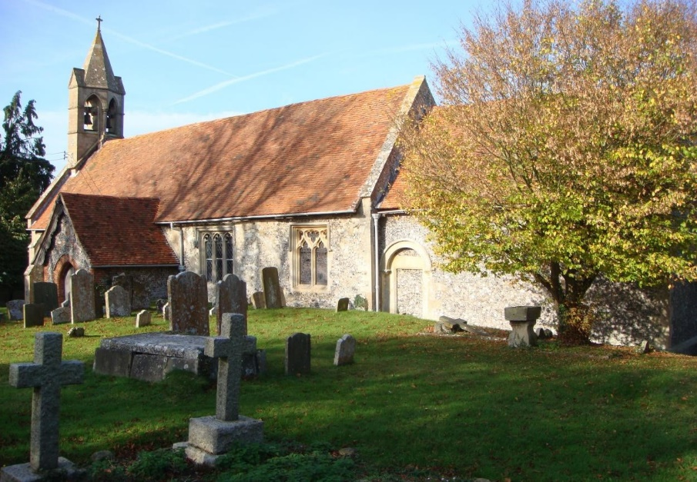
Ipsen is a working community of about 300 people. There is the last remaining post office in the Team area which is the hub of the village. The hamlet of Hailey falls within the parish and includes the popular King William pub with its magnificent views across the Chilterns. The local economy is mainly agricultural, but also within the village there are several thriving small businesses. There is a private nursery school, a well-supported cricket club, Village Hall and website. Ipsden is an artistic community. The St Mary’s Players is a lively and enthusiastic church-based drama group, who have staged an annual village pantomime for more than 15 years
www.ipsdenvillage.co.uk

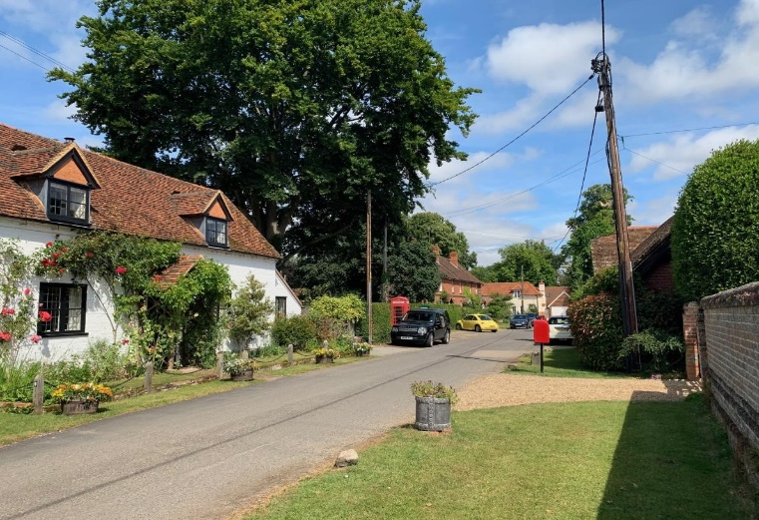
North Stoke & Mongewell
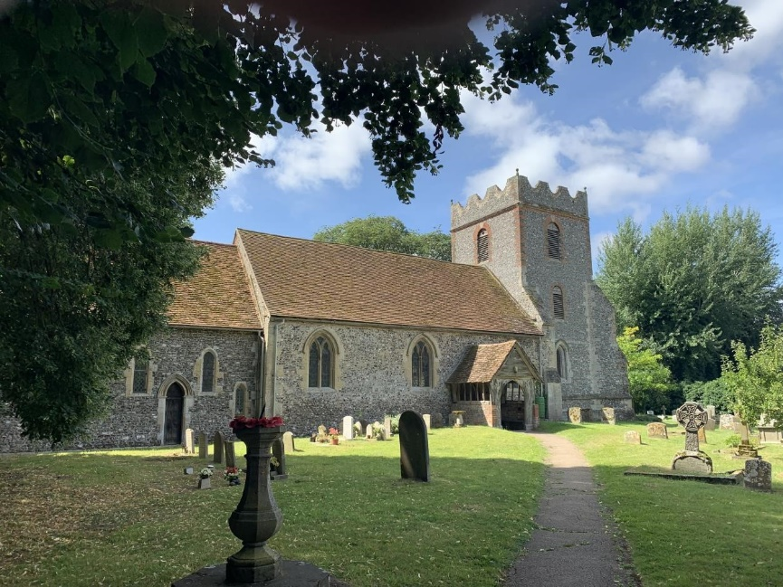
North Stoke is an attractive Thames-side village popular with commuters travelling to London from Goring station and those in retirement. for its peace and quiet. The Ridgeway footpath runs through the village and churchyard, so St Mary's church is regularly visited by walkers. North Stoke is currently a parish of about 200 people with a village hall and a golf course, but this is set to increase with the anticipated development of the Carmel College site in the hamlet of Mongewell.
The 13th century flint church of St Mary with its unique medieval wall paintings seats up to 100 people and the churchyard is well maintained. St Johns College, Cambridge are responsible for the maintenance of the chancel.

Appointment Process
Applicants should complete the application form available at www.oxford.anglican.org, giving as much information as possible and continuing on additional sheets as necessary. The completed form must be sent or emailed to
The Bishop of Dorchester
Church House Oxford
Langford Locks, Kidlington
Oxford OX5 1GF
Tel: 01865 375541
email: bishopdorchester@oxford.anglican.org
For further details or to arrange an informal visit to the parishes please contact the Team Rector:
The Revd Canon Kevin Davies,
Tel: 01491 680252.
Email: revkevdavies.langtree@yahoo.co.uk
CRB Enhanced Disclosure is required for this post.
The toll bridge at Whitchurch on Thames, looking towards St Mary’s Church
